FACE MASK DETECTION USING
CONVOLUTIONAL NEURAL NETWORK (CNN)

A Lab Mini-Project Report
Neural Network and Deep Learning

Submitted by:
Bhagya Lakshmi
25MDA10043

in partial fulfillment for the award of the degree of

MASTER OF BUSINESS ADMINISTRATION
IN
DATA SCIENCE AND ARTIFICIAL INTELLIGENCE


Chandigarh University
Academic Year 2026–2027
TABLE OF CONTENTS
CHAPTER 1 INTRODUCTION 4
1.1 Background and Motivation 4
1.2 Problem Statement 4
1.3 Project Objectives 4
1.4 Scope of the Project 5
CHAPTER 2 DATASET AND METHODOLOGY 6
2.1 Dataset Source and Description 6
2.2 Dataset Organisation and Classes 7
2.3 Exploratory Data Analysis 7
2.4 Image Preprocessing 8
2.5 Image Resizing and Normalisation 10
2.6 Training, Validation and Testing 10
2.7 CNN Architecture 11
2.8 Model Training 12
2.9 Evaluation Metrics 13
CHAPTER 3 IMPLEMENTATION 14
3.1 Tools and Technologies 14
3.2 Project Workflow 14
3.3 Dataset Loading and Preprocessing 15
3.4 CNN Model Building 16
3.5 Model Training and Validation 17
3.6 Model Evaluation and Prediction 18
3.7 Implementation Screenshots 20
CHAPTER 4 RESULTS AND DISCUSSION 22
4.1 Overview of Model Evaluation 22
4.2 Training and Validation Performance 22
4.3 Accuracy and Loss Analysis 24
4.4 Confusion Matrix 25
4.5 Precision, Recall and F1-Score 26
4.6 Correct and Incorrect Predictions 27
4.7 Discussion of Results 28
4.8 Limitations 28
CHAPTER 5 CONCLUSION AND FUTURE SCOPE 30
5.1 Conclusion 30
5.2 Learning Outcomes 30
5.3 Limitations 30
5.4 Future Scope 31
5.5 Final Remarks 31
REFERENCES 32
LIST OF FIGURES
Figure 2.1 — Dataset details printed by the notebook (image counts, image size and corrupted-image check) 6
Figure 2.2 — Training and validation image counts and class labels printed by the notebook 7
Figure 2.3 — Sample images from the dataset (10 With Mask and 10 Without Mask) 8
Figure 2.4 — Class distribution of the dataset 8
Figure 2.5 — A batch of resized and rescaled training images (before augmentation) 9
Figure 2.6 — Architecture of the CNN model (drawn from the notebook’s model summary) 12
Figure 3.1 — Workflow of the face mask detection project 14
Figure 3.2 — Code for dataset loading, corrupted-image check and image generators 16
Figure 3.3 — Code for building and compiling the CNN model 17
Figure 3.4 — Code for training the model with early stopping 17
Figure 3.5 — Training output of all 25 epochs (notebook output) 18
Figure 3.6 — Code for model evaluation, metrics and classification report 19
Figure 3.7 — Code for displaying predictions and incorrectly classified images 20
Figure 3.8 — CNN model summary (notebook output) 21
Figure 3.9 — Evaluation output: image count, test loss and test accuracy (notebook output) 21
Figure 4.1 — Training accuracy (left) and validation accuracy (right) over 25 epochs 24
Figure 4.2 — Training loss (left) and validation loss (right) over 25 epochs 24
Figure 4.3 — Confusion matrix of the CNN model 26
Figure 4.4 — Evaluation metrics, confusion matrix and classification report (notebook output) 27
Figure 4.5 — Sample prediction outputs for 20 images (A = actual label, P = predicted label) 27
LIST OF TABLES
Table 2.1 — Characteristics of the dataset 6
Table 2.2 — Class folders, label values and image counts 7
Table 2.3 — EDA observations 7
Table 2.4 — Data augmentation settings used for training 9
Table 2.5 — Image loading settings 10
Table 2.6 — Division of the dataset 10
Table 2.7 — Purpose of the main CNN components 11
Table 2.8 — CNN layers used in the project (from the model summary) 11
Table 2.9 — Training configuration 12
Table 3.1 — Tools and technologies used 14
Table 4.1 — Summary of evaluation results 22
Table 4.2 — Training and validation results for all 25 epochs 23
Table 4.3 — Final and best epoch values from the training history 24
Table 4.4 — Confusion matrix 25
Table 4.5 — Meaning of the confusion-matrix cells 25
Table 4.6 — Accuracy, precision, recall and F1-score 26
Table 4.7 — Classification report (as printed by the notebook) 26

CHAPTER 1
INTRODUCTION

1.1 Background and Motivation
Face mask detection is an application of computer vision, the area of artificial intelligence that allows computers to understand images. In hospitals, laboratories, public buildings and workplaces, face masks are used to reduce the spread of airborne infections. Checking mask usage by people is time-consuming and may not be consistent. An automatic system that can look at a face image and decide whether a mask is worn can support such monitoring.
Deep learning, and in particular the Convolutional Neural Network (CNN), is well suited to this task. A CNN learns useful visual patterns such as edges, textures and shapes directly from image pixels, so the patterns do not have to be designed by hand. CNNs are widely used for image classification for this reason.
This lab mini-project builds a CNN that classifies a face image into two classes: With Mask and Without Mask. The work was carried out in a Jupyter Notebook using Python, TensorFlow/Keras and scikit-learn, and covers image preprocessing, data augmentation, model building, training and evaluation.

1.2 Problem Statement
Given a colour face image, the problem is to decide whether the person in the image is wearing a face mask. This is a binary image-classification problem with two classes, With Mask and Without Mask. The project addresses how to prepare a dataset of 3,584 face images, design and train a CNN on it, and judge how well the trained model classifies images using accuracy, precision, recall, F1-score and a confusion matrix.

1.3 Project Objectives
- To understand image classification using Convolutional Neural Networks.
- To perform image preprocessing, including resizing, normalisation and data augmentation.
- To develop and train a CNN model for binary face mask classification.
- To evaluate the model using accuracy, precision, recall, F1-score and a confusion matrix.
- To analyse the predictions and identify possible reasons for incorrect classifications.
- To gain practical experience in applying deep learning to a computer-vision problem.

1.4 Scope of the Project
The project is limited to classifying still face images into With Mask and Without Mask using a CNN trained from scratch on a dataset of 3,584 images. It covers the full laboratory workflow from dataset exploration to model evaluation and prediction analysis.
The following are not part of this project and are not claimed as implemented: real-time video or webcam detection, locating faces inside larger scenes, recognising incorrectly worn masks as a separate class, and deployment as a web or mobile application. Some of these are discussed as future scope in Chapter 5. The project is an academic laboratory exercise and not a production safety system.

CHAPTER 2
DATASET AND METHODOLOGY

2.1 Dataset Source and Description
The project uses a face mask image dataset provided by Edure Learning during the internship training programme. The dataset was stored in a local folder on the student's computer and used to develop a Convolutional Neural Network (CNN) model for face mask detection. It contains 3,584 colour images of faces, divided equally into two classes: With Mask and Without Mask, with 1,792 images in each class. The dataset was used to train and evaluate the model's ability to classify face images into these two categories. Since the dataset was provided as part of the internship training, the original dataset author and public download link were not available in the project records.
Dataset Source: Edure Learning, internship training materials (dataset provided during the internship programme).
Table 2.1 — Characteristics of the dataset
Characteristic | Description
Total number of images | 3,584
Number of classes | 2 (With Mask, Without Mask)
Images per class | 1,792 in each class
Corrupted images found | 0 (checked using the Pillow library)
Image type | Colour face images (3 channels)
Original image size | 66 × 92 pixels (width × height), checked for the first With Mask image only
Task | Binary image classification

Only the first image of the With Mask folder was checked for its original size, so the sizes of the other images were not recorded. Because image sizes can differ, all images were resized to a fixed size before training (Section 2.5).

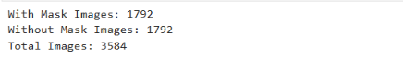

Figure 2.1 — Dataset details printed by the notebook (image counts, image size and corrupted-image check)

2.2 Dataset Organisation and Classes
The images are kept in two sub-folders inside one main dataset folder, one folder for each class. Keras reads the folder names and uses them as class labels. Class indices are assigned in alphabetical order of the folder names, which gave the mapping shown in Table 2.2 and Figure 2.2.
Table 2.2 — Class folders, label values and image counts
Folder name | Class | Numeric label | Images
with_mask 1 | With Mask | 0 | 1,792
without_mask | Without Mask | 1 | 1,792
Total |  |  | 3,584
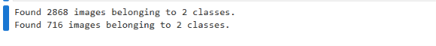
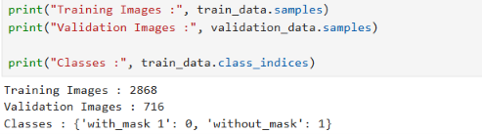
Figure 2.2 — Training and validation image counts and class labels printed by the notebook
The model has a single output between 0 and 1. A value close to 0 means With Mask and a value close to 1 means Without Mask. In the evaluation, Without Mask (label 1) is treated as the positive class, which is the default in scikit-learn.

2.3 Exploratory Data Analysis
Exploratory Data Analysis (EDA) was carried out to understand the dataset before training. The number of images in each folder was counted, 20 sample images (10 from each class) were displayed, the class distribution was plotted, the size of one image was checked, and every image was tested for corruption.
Table 2.3 — EDA observations
EDA check | Finding
Total images | 3,584
Class balance | 1,792 With Mask and 1,792 Without Mask (balanced)
Corrupted images | None found
Visual inspection | Images show different face angles, lighting conditions and backgrounds

Because both classes have the same number of images, the model is not biased towards one class by the data distribution. The variety seen in the sample images is useful because the model must work on faces that are not identical in pose and lighting.
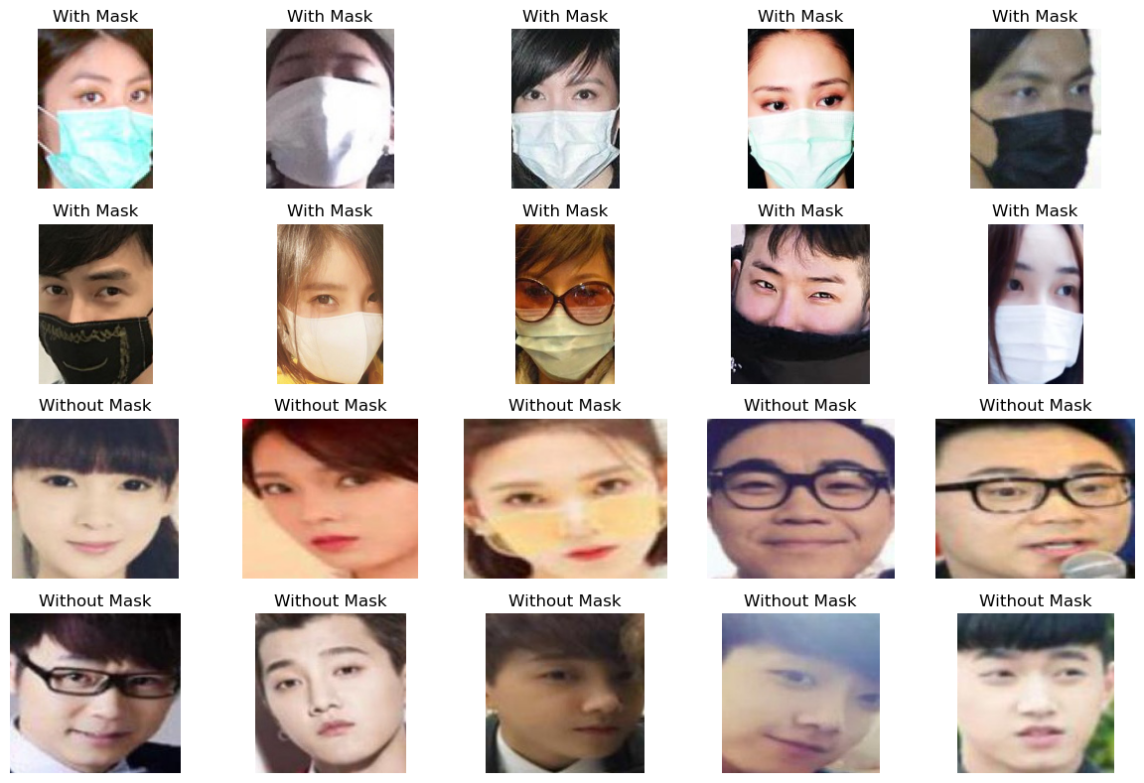
Figure 2.3 — Sample images from the dataset (10 With Mask and 10 Without Mask)
Figure 2.3 shows the first 10 images of each class as read from the folders. The With Mask images show surgical, cloth and N95-type masks, and the Without Mask images show faces of different people with varied poses, lighting and backgrounds.
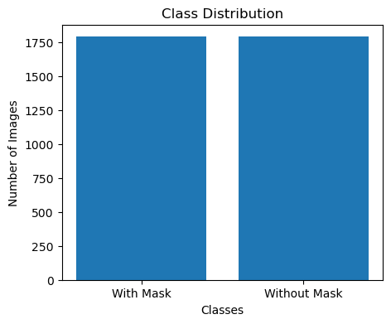
Figure 2.4 — Class distribution of the dataset

2.4 Image Preprocessing
Raw images cannot be given directly to a neural network because they differ in size and their pixel values are large integers. The preprocessing in this project uses the Keras ImageDataGenerator class and flow_from_directory method, which read the images from the class folders and prepare them in batches. The main steps are listed below.
- Read images from the class folders; the folder name becomes the label (binary mode).
- Resize every image to 128 × 128 pixels.
- Rescale pixel values from the range 0–255 to the range 0–1.
- Divide the images into a training subset and a validation subset (80:20).
- Apply random data augmentation to the training images.
Data augmentation creates slightly changed versions of images during training so that the model sees more variety. The images stored on disk are not altered and the dataset size remains 3,584. The augmentation settings used in the training generators are given in Table 2.4.
Table 2.4 — Data augmentation settings used for training
Setting | Value | Purpose
rotation_range | 20 degrees | Handles slightly tilted faces
horizontal_flip | True | Handles left/right orientation
zoom_range | 0.2 | Handles faces at different distances
width_shift_range | 0.2 | Handles faces that are off-centre horizontally
height_shift_range | 0.2 | Handles faces that are off-centre vertically

The notebook also defines a separate generator with brightness adjustment (brightness_range=[0.8, 1.2]), but the generators that were used to train the model (Annexure A.1) do not include it, so brightness adjustment was not applied in training.
Figure 2.5 shows one batch of training images after loading, resizing to 128 × 128 pixels and rescaling. This batch was drawn from the first generator created in the notebook, which applies rescaling only, so the images are shown before augmentation.
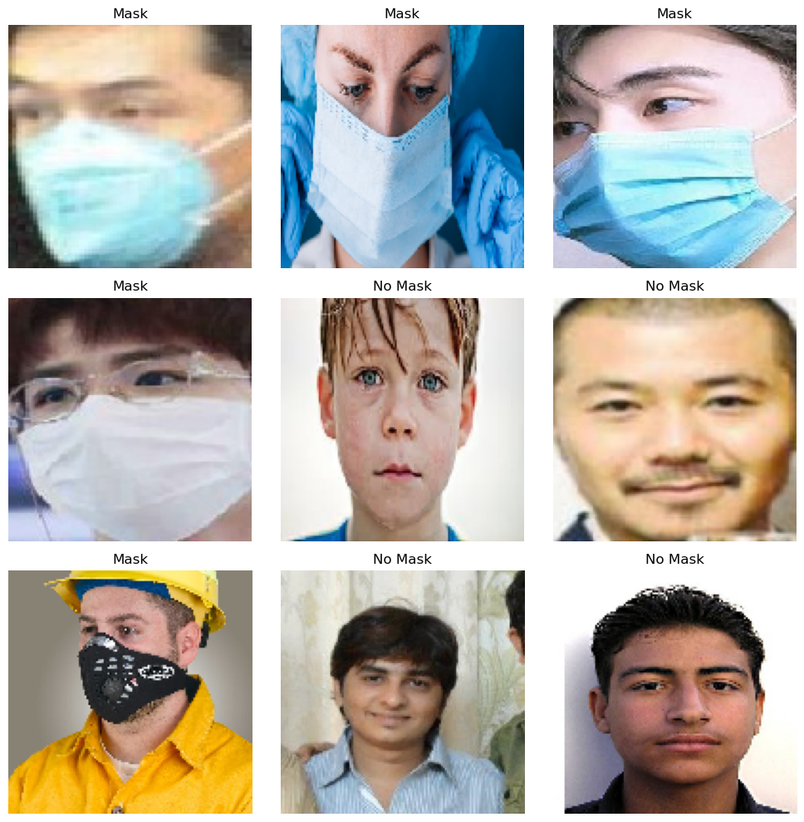
Figure 2.5 — A batch of resized and rescaled training images (before augmentation)

2.5 Image Resizing and Normalisation
Resizing. A CNN needs inputs of the same size. All images were resized to 128 × 128 pixels with three colour channels, so each model input has the shape 128 × 128 × 3. A batch size of 32 images was used.
Normalisation. Each pixel in a colour image has a value from 0 to 255. Dividing by 255 (rescale=1./255) changes the range to 0–1. Smaller input values make training more stable and usually faster, because the weights of the network are updated in smaller and more balanced steps.
Table 2.5 — Image loading settings
Parameter | Value
Target image size | 128 × 128 pixels
Colour channels | 3 (input shape 128 × 128 × 3)
Pixel rescaling | 1/255 (0–255 to 0–1)
Batch size | 32
Class mode | Binary
Validation split | 0.2

2.6 Training, Validation and Testing
The dataset was divided using the validation_split=0.2 option, giving an 80:20 split. The training set is used to adjust the weights of the network. The validation set is used during training to check how the model performs on images it is not trained on, which helps to detect overfitting. A test set is normally kept completely separate for the final evaluation.
Table 2.6 — Division of the dataset
Subset | Images | Share | Purpose
Training | 2,868 | 80% | Learn the model weights
Validation | 716 | 20% | Monitor performance during training
Evaluation (whole dataset) | 3,584 | 100% | Final metrics, confusion matrix and predictions

The notebook did not create a separate test folder. After training, the final evaluation re-loaded the complete dataset folder (3,584 images, rescaling only, no shuffling), which includes the training and validation images. The results in Chapter 4 should be read with this in mind (see Sections 4.1 and 4.8). Also, one generator object was used to create both subsets during training, so the augmentation settings in Table 2.4 were also applied to the validation images.

2.7 CNN Architecture
A CNN is made of layers that each perform a simple job. Together they turn an image into a single prediction. The purpose of each layer type used in this project is explained in Table 2.7.
Table 2.7 — Purpose of the main CNN components
Component | Purpose in simple terms
Convolutional layer (Conv2D) | Slides small filters (3 × 3) over the image to detect patterns such as edges, then more complex shapes in later layers.
ReLU activation | Keeps positive values and sets negative values to zero. It lets the network learn non-linear patterns.
Pooling layer (MaxPooling2D) | Keeps the strongest value in each 2 × 2 region. It halves the image size, reduces computation and keeps the key features.
Flatten layer | Converts the 2-D feature maps into one long list of numbers so that dense layers can use them.
Dense layer | A fully connected layer that combines all features to learn high-level patterns.
Dropout layer | Randomly switches off a fraction of neurons during training to reduce overfitting.
Output layer (Sigmoid) | A single neuron that gives a value between 0 and 1, interpreted as the probability of the class Without Mask.

The architecture implemented in the notebook is a Sequential model with three convolution–pooling blocks followed by a dense classifier. Its layers, output shapes and parameter counts, taken from the notebook’s model summary (Figure 3.8), are given in Table 2.8, and the architecture is drawn in Figure 2.6.
Table 2.8 — CNN layers used in the project (from the model summary)
Layer | Configuration | Output shape | Parameters
Conv2D | 32 filters, 3 × 3, ReLU | 126 × 126 × 32 | 896
MaxPooling2D | 2 × 2 | 63 × 63 × 32 | 0
Conv2D | 64 filters, 3 × 3, ReLU | 61 × 61 × 64 | 18,496
MaxPooling2D | 2 × 2 | 30 × 30 × 64 | 0
Conv2D | 128 filters, 3 × 3, ReLU | 28 × 28 × 128 | 73,856
MaxPooling2D | 2 × 2 | 14 × 14 × 128 | 0
Flatten | – | 25,088 | 0
Dense | 128 neurons, ReLU | 128 | 3,211,392
Dropout | rate 0.5 | 128 | 0
Dense (output) | 1 neuron, Sigmoid | 1 | 129
Total |  |  | 3,304,769

The model has 3,304,769 parameters, all of them trainable. The image becomes slightly smaller after each convolution because no padding is used, and is halved by each pooling layer. Most parameters (3,211,392) are in the first dense layer, because it connects all 25,088 flattened features to 128 neurons.
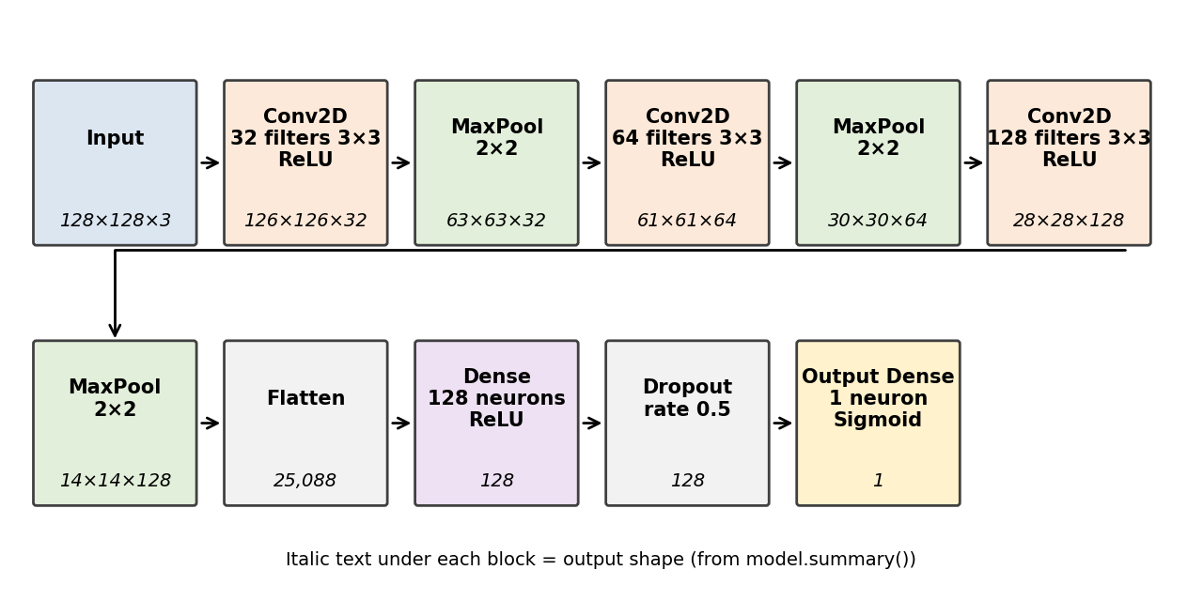
Figure 2.6 — Architecture of the CNN model (drawn from the notebook’s model summary)

2.8 Model Training
Training means adjusting the weights of the network so that its predictions move closer to the true labels. In each step the model predicts a batch of images, a loss function measures the error, and an optimiser changes the weights to reduce that error. This is repeated over all batches, and one full pass through the training images is called an epoch.
- Loss function – binary cross-entropy: suitable for two-class problems with a sigmoid output. It gives a large penalty when the model is confident but wrong.
- Optimiser – Adam: an adaptive method that adjusts the learning rate of each weight and usually trains faster than basic gradient descent. The default learning rate of 0.001 was used.
- Metric – accuracy: the share of images classified correctly, reported after every epoch for both the training and validation sets.
- EarlyStopping callback: watches the validation loss and is set to stop training if it does not improve for 5 epochs in a row, keeping the best weights.
Table 2.9 — Training configuration
Hyperparameter | Value
Optimiser | Adam
Loss function | Binary cross-entropy
Learning rate | Default (0.001)
Batch size | 32
Number of epochs | 25 (maximum)
Steps per epoch | 90 training steps
Early stopping | Monitor: val_loss; patience: 5; restore_best_weights: True
Validation strategy | 80% training, 20% validation

After each epoch the model is also run on the validation images. The validation images are not used to change the weights; they only show whether the model is generalising to new data. The training log of all 25 epochs is shown in Figure 3.5 and Table 4.2.

2.9 Evaluation Metrics
The predictions of the trained model are compared with the true labels. The sigmoid output is converted into a class using a threshold of 0.5: values above 0.5 are Without Mask and other values are With Mask. In the formulas below, the positive class is Without Mask, and TP, TN, FP and FN denote true positives, true negatives, false positives and false negatives.

2.9.1 Confusion Matrix
A confusion matrix is a table that counts correct and incorrect predictions for each class. Rows show the actual class and columns show the predicted class. It shows not only how many errors were made but also which kind.

2.9.2 Accuracy
Accuracy is the proportion of all images that were classified correctly.
Accuracy = (TP + TN) / (TP + TN + FP + FN)

2.9.3 Precision
Precision shows how many of the images predicted as Without Mask were actually Without Mask. A high value means few false alarms.
Precision = TP / (TP + FP)

2.9.4 Recall
Recall shows how many of the actual Without Mask images were found by the model. A high value means few missed cases.
Recall = TP / (TP + FN)

2.9.5 F1-Score
The F1-score is the harmonic mean of precision and recall. It is high only when both are high.
F1-Score = 2 × (Precision × Recall) / (Precision + Recall)

CHAPTER 3
IMPLEMENTATION

3.1 Tools and Technologies
Table 3.1 — Tools and technologies used
Technology | Purpose
Python 3 | Main programming language
Jupyter Notebook | Interactive environment for code, outputs and notes
TensorFlow / Keras | Building, training and evaluating the CNN; image generators; EarlyStopping callback
NumPy and Pandas | Numerical operations and data handling
Pillow (PIL) | Opening images, reading image size and checking for corrupted files
Matplotlib | Plotting images, class distribution, training curves and confusion matrix
scikit-learn | Accuracy, precision, recall, F1-score, confusion matrix, classification report
Operating system | Windows (as seen from the file paths in the notebook)

The TensorFlow message in the notebook states that GPU support is not available on native Windows for the TensorFlow version used, so training did not use a GPU.

3.2 Project Workflow
The project follows the sequence of steps shown in Figure 3.1. Each step corresponds to one task of the notebook.
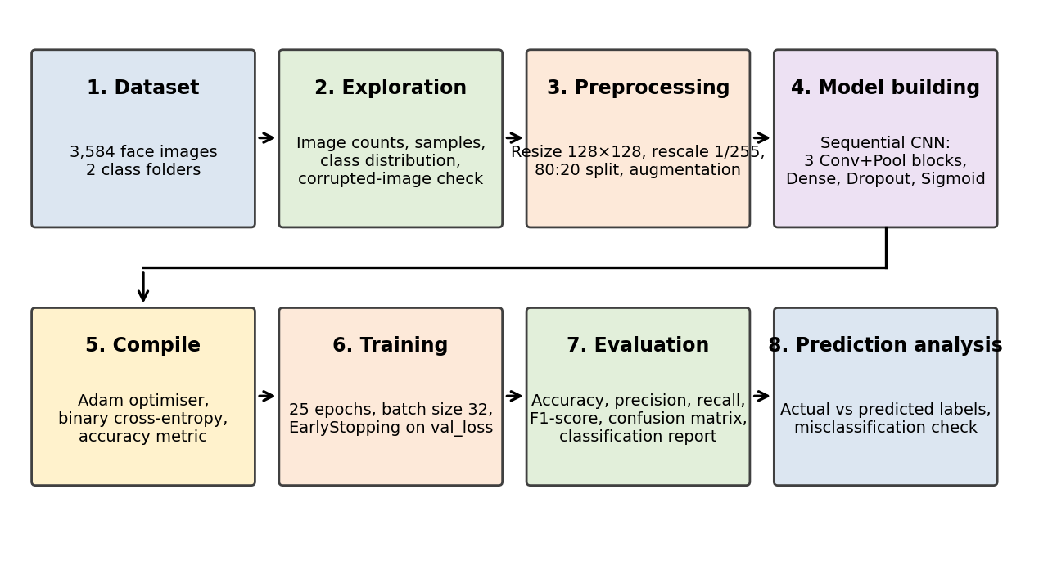
Figure 3.1 — Workflow of the face mask detection project
- Import the required libraries and set the dataset paths.
- Explore the dataset: count images, view samples, plot the class distribution and check for corrupted images.
- Create image generators that resize, rescale, augment and split the images.
- Build the CNN model using the Keras Sequential API.
- Compile the model with the Adam optimiser and binary cross-entropy loss.
- Train the model for up to 25 epochs with early stopping while monitoring validation performance.
- Plot the training and validation accuracy and loss.
- Predict on images and calculate accuracy, precision, recall, F1-score and the confusion matrix.
- Display predictions and check for incorrectly classified images, then discuss the results.

3.3 Dataset Loading and Preprocessing
The paths of the two class folders were stored in variables, and os.listdir() was used to count the images (1,792 per class). A loop opened every file with Pillow and called verify(); no corrupted image was found. Sample images and a bar chart of the class counts were then displayed with Matplotlib.
Preprocessing was done with ImageDataGenerator using rescale=1./255, validation_split=0.2 and the augmentation settings in Table 2.4. Two calls to flow_from_directory with target_size=(128, 128), batch_size=32 and class_mode="binary" produced the training generator (2,868 images) and the validation generator (716 images). The code is shown in Figure 3.2.
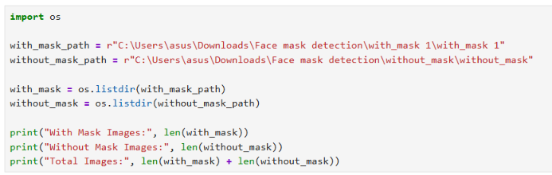
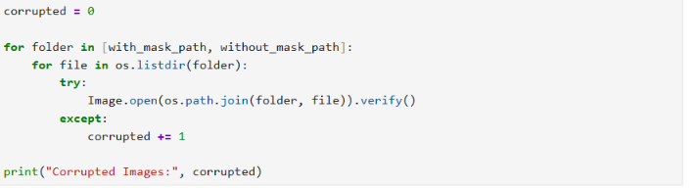
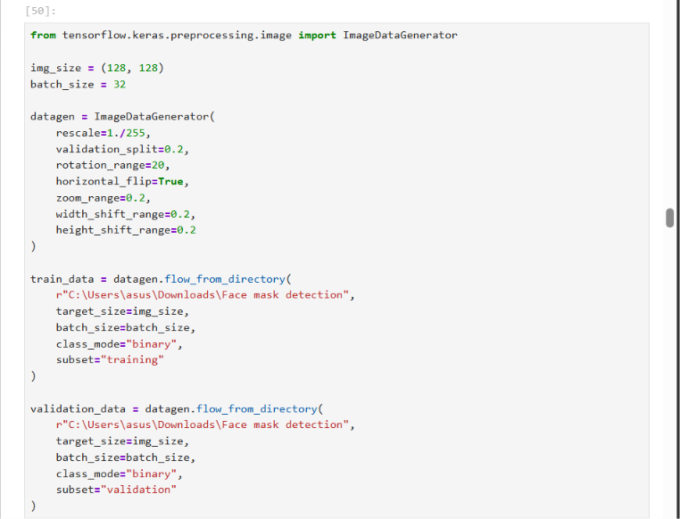

Figure 3.2 — Code for dataset loading, corrupted-image check and image generators

3.4 CNN Model Building
The model was created with Sequential() and layers were added one after another: three Conv2D layers with 32, 64 and 128 filters of size 3 × 3 and ReLU activation, each followed by MaxPooling2D of size 2 × 2; then Flatten, a Dense layer of 128 neurons with ReLU, a Dropout layer with rate 0.5, and a final Dense layer with one neuron and sigmoid activation. The model was compiled with optimizer="adam", loss="binary_crossentropy" and metrics=["accuracy"]. The code is shown in Figure 3.3 and the resulting model summary in Figure 3.8.
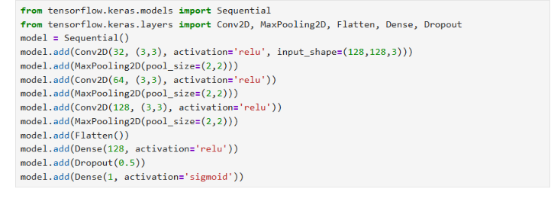
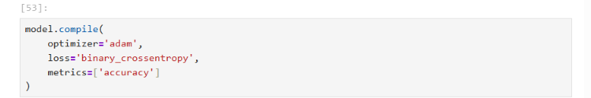
Figure 3.3 — Code for building and compiling the CNN model

3.5 Model Training and Validation
Training was started with the fit() method using the training generator, the validation generator and up to 25 epochs, together with an EarlyStopping callback that monitors the validation loss with a patience of 5 epochs (Figure 3.4). Each epoch had 90 training steps. Training ran for all 25 epochs, because the validation loss kept improving until epoch 23 and so the early-stopping condition was never reached.
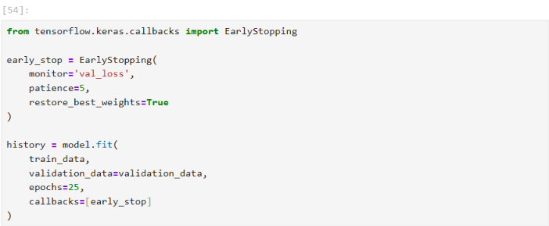

Figure 3.4 — Code for training the model with early stopping
Figure 3.5 shows the complete training output of all 25 epochs. Each epoch took between 70 and 87 seconds, and the printed epoch times add up to about 1,889 seconds (roughly 31 minutes). The history object stores the accuracy and loss of every epoch and was used to draw the learning curves in Chapter 4.
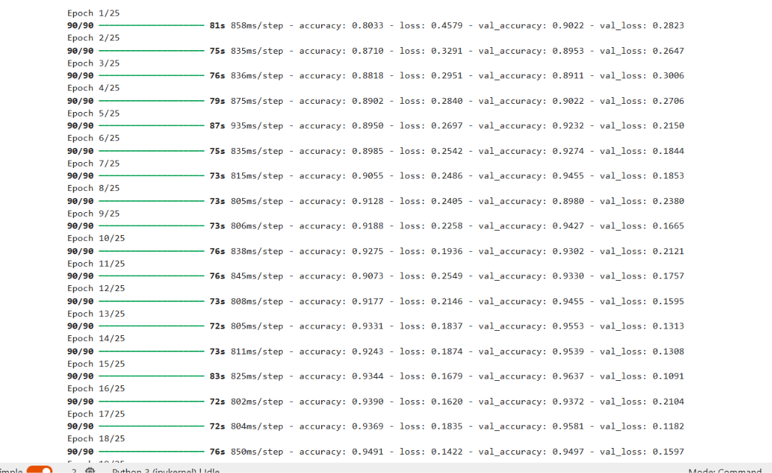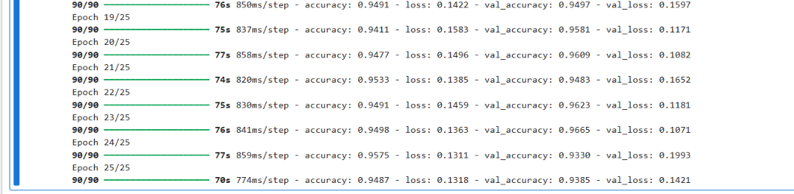

Figure 3.5 — Training output of all 25 epochs (notebook output)

3.6 Model Evaluation and Prediction
For the final evaluation, the notebook created a new generator that re-loads the complete dataset folder (3,584 images) with rescaling only and shuffle=False, so that the order of the predictions matches the order of the true labels. model.evaluate() gave the test loss and accuracy. The probabilities from model.predict() were converted to classes with a threshold of 0.5 (above 0.5 is Without Mask), and scikit-learn was used to calculate accuracy, precision, recall, F1-score, the confusion matrix and the classification report (Figure 3.6).
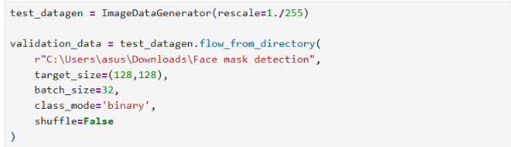
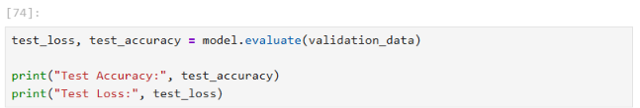
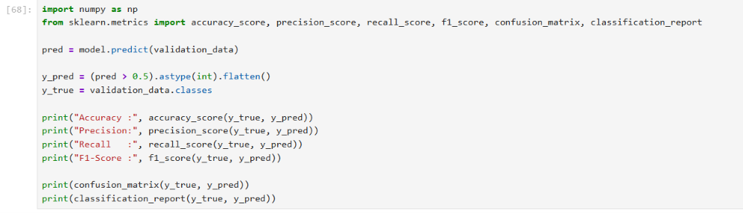
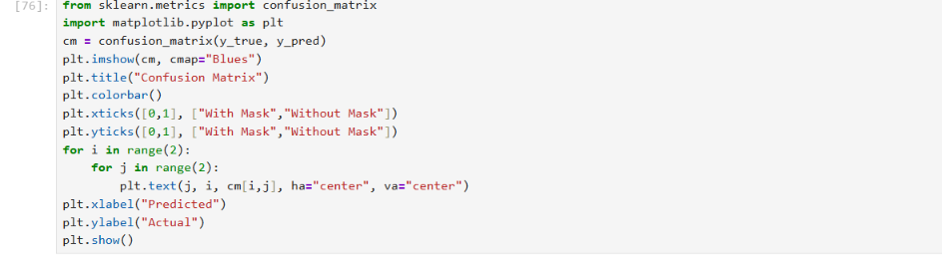
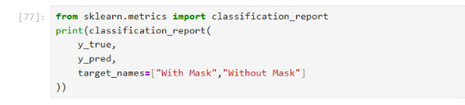

Figure 3.6 — Code for model evaluation, metrics and classification report
For prediction analysis, one batch of images was taken from the evaluation generator and displayed with its actual and predicted labels, and a second cell was written to display up to six incorrectly classified images from a batch (Figure 3.7).
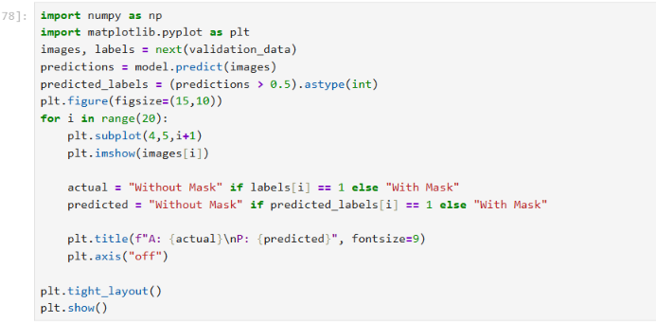
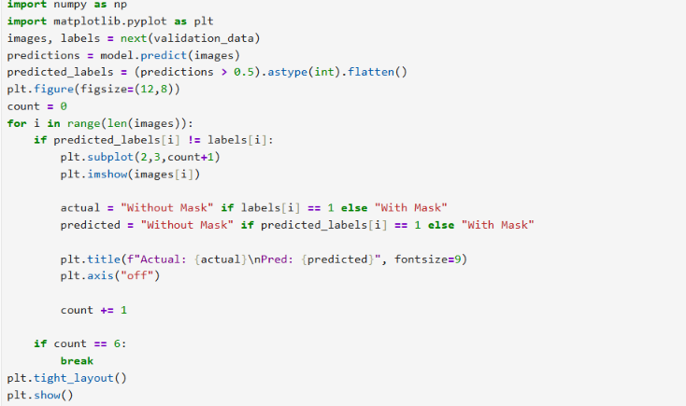

Figure 3.7 — Code for displaying predictions and incorrectly classified images

3.7 Implementation Screenshots
The model summary and the evaluation output are reproduced below word for word from the project notebook. The dataset, training and metric outputs appear in Figures 2.1, 2.2, 3.5 and 4.4.
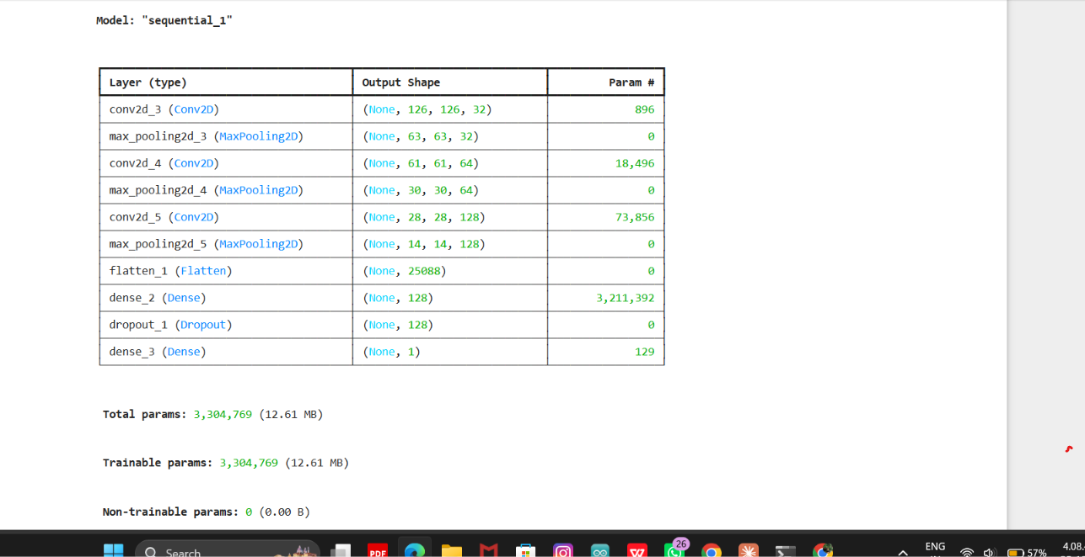

Figure 3.8 — CNN model summary (notebook output)

Figure 3.9 — Evaluation output: image count, test loss and test accuracy (notebook output)

CHAPTER 4
RESULTS AND DISCUSSION

4.1 Overview of Model Evaluation
The CNN was evaluated using accuracy, precision, recall, F1-score and a confusion matrix. The results obtained for the model are summarised in Table 4.1.
Table 4.1 — Summary of evaluation results
Metric | Value
Test accuracy | 97.66% (0.9765625)
Test loss | 0.0642 (0.06415515393018723)
Precision | 98.63%
Recall | 96.65%
F1-score | 97.63%
Confusion matrix | [[1768, 24], [60, 1732]]
Images evaluated | 3,584

The metrics are calculated for the positive class Without Mask (label 1), and the confusion matrix has rows as actual classes and columns as predicted classes, in the order With Mask, Without Mask. The values agree with each other: the confusion matrix gives 3,500 correct predictions out of 3,584, which is 97.66%.
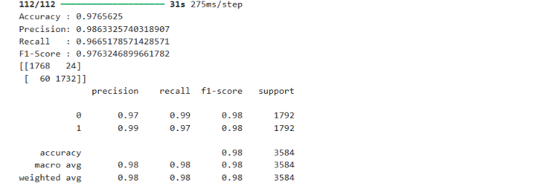

4.2 Training and Validation Performance
Training and validation performance were recorded after each of the 25 epochs (Table 4.2). Training accuracy and loss show how well the model fits the images it learns from. Validation accuracy and loss show how well it performs on validation images that are not used for weight updates. If both improve together and stay close, the model is generalising well. If training results keep improving while validation results become worse, the model is overfitting.
Table 4.2 — Training and validation results for all 25 epochs
Epoch | Training accuracy | Training loss | Validation accuracy | Validation loss | Time (s)
1 | 0.8033 | 0.4579 | 0.9022 | 0.2823 | 81
2 | 0.8710 | 0.3291 | 0.8953 | 0.2647 | 75
3 | 0.8818 | 0.2951 | 0.8911 | 0.3006 | 76
4 | 0.8902 | 0.2840 | 0.9022 | 0.2706 | 79
5 | 0.8950 | 0.2697 | 0.9232 | 0.2150 | 87
6 | 0.8985 | 0.2542 | 0.9274 | 0.1844 | 75
7 | 0.9055 | 0.2486 | 0.9455 | 0.1853 | 73
8 | 0.9128 | 0.2405 | 0.8980 | 0.2380 | 73
9 | 0.9188 | 0.2258 | 0.9427 | 0.1665 | 73
10 | 0.9275 | 0.1936 | 0.9302 | 0.2121 | 76
11 | 0.9073 | 0.2549 | 0.9330 | 0.1757 | 76
12 | 0.9177 | 0.2146 | 0.9455 | 0.1595 | 73
13 | 0.9331 | 0.1837 | 0.9553 | 0.1313 | 72
14 | 0.9243 | 0.1874 | 0.9539 | 0.1308 | 73
15 | 0.9344 | 0.1679 | 0.9637 | 0.1091 | 83
16 | 0.9390 | 0.1620 | 0.9372 | 0.2104 | 72
17 | 0.9369 | 0.1835 | 0.9581 | 0.1182 | 72
18 | 0.9491 | 0.1422 | 0.9497 | 0.1597 | 76
19 | 0.9411 | 0.1583 | 0.9581 | 0.1171 | 75
20 | 0.9477 | 0.1496 | 0.9609 | 0.1082 | 77
21 | 0.9533 | 0.1385 | 0.9483 | 0.1652 | 74
22 | 0.9491 | 0.1459 | 0.9623 | 0.1181 | 75
23 | 0.9498 | 0.1363 | 0.9665 | 0.1071 | 76
24 | 0.9575 | 0.1311 | 0.9330 | 0.1993 | 77
25 | 0.9487 | 0.1318 | 0.9385 | 0.1421 | 70
Table 4.3 — Final and best epoch values from the training history
Measure | Training | Validation
Final epoch (25) – accuracy | 0.9487 | 0.9385
Final epoch (25) – loss | 0.1318 | 0.1421
Highest accuracy | 0.9575 (epoch 24) | 0.9665 (epoch 23)
Lowest loss | 0.1311 (epoch 24) | 0.1071 (epoch 23)

4.3 Accuracy and Loss Analysis
Figures 4.1 and 4.2 show the training and validation accuracy and loss against the epoch number. The epoch axis starts at 0, which is epoch 1 in Table 4.2.
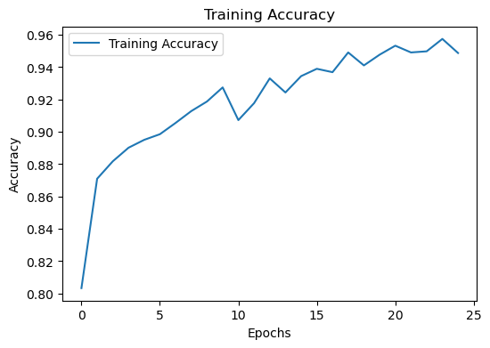 | 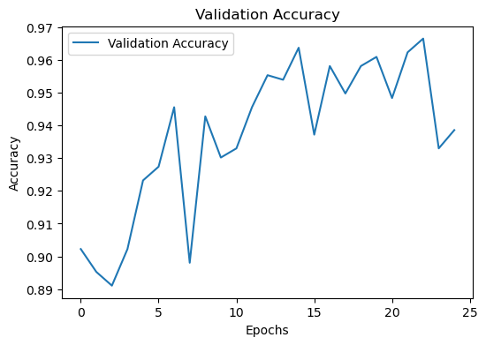

Figure 4.1 — Training accuracy (left) and validation accuracy (right) over 25 epochs
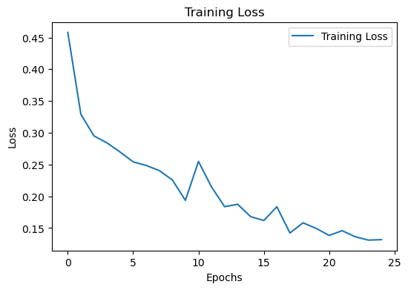 | 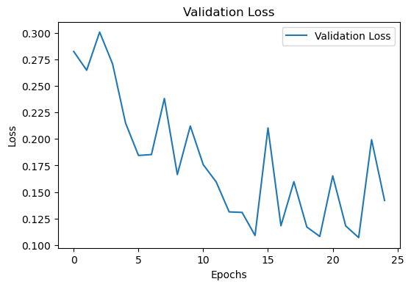

Figure 4.2 — Training loss (left) and validation loss (right) over 25 epochs
Observations from Table 4.2 and the graphs:
- Training accuracy rose from 0.8033 in epoch 1 to 0.9487 in epoch 25 (highest 0.9575 in epoch 24), and training loss fell from 0.4579 to 0.1318.
- Validation accuracy started at 0.9022, was lowest at 0.8911 in epoch 3, reached its highest value of 0.9665 in epoch 23, and was 0.9385 in epoch 25.
- Validation loss started at 0.2823, was highest at 0.3006 in epoch 3, reached its lowest value of 0.1071 in epoch 23, and was 0.1421 in epoch 25.
- Validation accuracy was higher than training accuracy in 20 of the 25 epochs.
The model shows convergence: the loss fell and the accuracy rose over the epochs, and the validation results ended close to the training results (accuracy 0.9385 against 0.9487, loss 0.1421 against 0.1318 in epoch 25). There is no sign of overfitting, because the validation results did not get worse while the training results improved, and no sign of underfitting, because both accuracies are above 0.93 at the end.
The validation curves are not smooth. Validation accuracy dipped in several epochs, for example epochs 8, 16 and 24, which is probably due to the small validation set of 716 images and the random augmentation that was also applied to it. Validation accuracy being higher than training accuracy in most epochs can happen because dropout is active only during training and the training images are augmented. Early stopping did not stop the training, since the best validation loss occurred in epoch 23 and only two epochs followed it.

4.4 Confusion Matrix
Table 4.4 — Confusion matrix
 | Predicted: With Mask | Predicted: Without Mask | Row total
Actual: With Mask | 1,768 (TN) | 24 (FP) | 1,792
Actual: Without Mask | 60 (FN) | 1,732 (TP) | 1,792
Column total | 1,828 | 1,756 | 3,584

The matrix is written as [[1768, 24], [60, 1732]] and is drawn in Figure 4.3. The diagonal values are the correct predictions and the off-diagonal values are the errors. Their meaning is explained in Table 4.5.
Table 4.5 — Meaning of the confusion-matrix cells
Cell | Count | Meaning
True Negative (TN) | 1,768 | With Mask image correctly predicted as With Mask
False Positive (FP) | 24 | With Mask image wrongly predicted as Without Mask
False Negative (FN) | 60 | Without Mask image wrongly predicted as With Mask
True Positive (TP) | 1,732 | Without Mask image correctly predicted as Without Mask

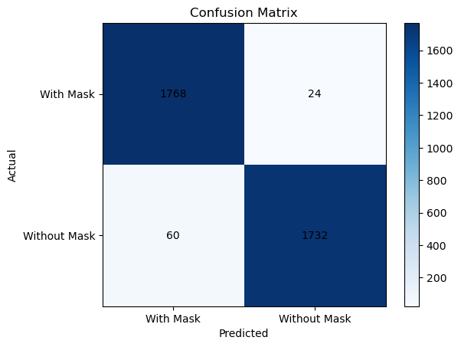
Figure 4.3 — Confusion matrix of the CNN model

4.5 Precision, Recall and F1-Score
Precision, recall and F1-score for the positive class Without Mask are shown in Table 4.6 together with the calculation from the confusion matrix. They match the values printed by the notebook (Figure 4.4).
Table 4.6 — Accuracy, precision, recall and F1-score
Metric | Calculation | Value
Accuracy | (1732 + 1768) / 3584 | 97.66%
Precision | 1732 / (1732 + 24) | 98.63%
Recall | 1732 / (1732 + 60) | 96.65%
F1-score | 2 × (0.9863 × 0.9665) / (0.9863 + 0.9665) | 97.63%

Precision is higher than recall. This means that when the model says a person is without a mask it is usually right (few false alarms), but it misses somewhat more of the real without-mask cases (60 missed against 24 false alarms). The F1-score of 97.63% shows a good balance between the two. The classification report printed by the notebook is given in Table 4.7.
Table 4.7 — Classification report (as printed by the notebook)
Class | Precision | Recall | F1-score | Support
With Mask | 0.97 | 0.99 | 0.98 | 1792
Without Mask | 0.99 | 0.97 | 0.98 | 1792
Accuracy |  |  | 0.98 | 3584
Macro average | 0.98 | 0.98 | 0.98 | 3584
Weighted average | 0.98 | 0.98 | 0.98 | 3584

Figure 4.4 — Evaluation metrics, confusion matrix and classification report (notebook output)

4.6 Correct and Incorrect Predictions
Of the 3,584 images evaluated, 3,500 were classified correctly and 84 were classified incorrectly (an error rate of 2.34%). Of the errors, 24 were people wearing masks who were predicted as not wearing one, and 60 were people not wearing masks who were predicted as wearing one. In a safety-monitoring setting the second type may matter more, because a person without a mask goes unnoticed.
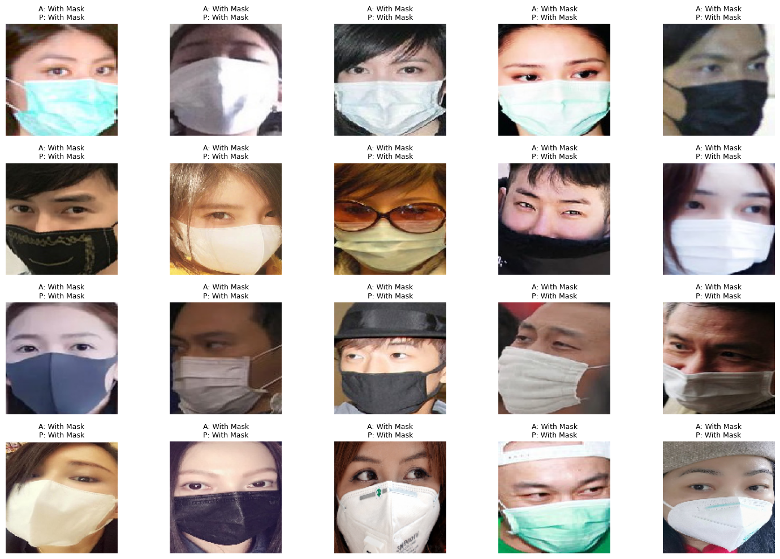
Figure 4.5 — Sample prediction outputs for 20 images (A = actual label, P = predicted label)
Figure 4.5 shows the actual and predicted labels of 20 images. All 20 images are With Mask images and all 20 were predicted correctly as With Mask. Because the evaluation generator was not shuffled, the first batch contains only images from the first class folder, so this figure does not show any Without Mask image.
The notebook cell written to display incorrectly classified images (Figure 3.7) produced an empty plot, because the batch that it examined contained no wrongly classified image. As a result, the notebook has no example images for the 84 errors, which are known only from the confusion matrix. Reasons for such errors in image-classification tasks of this kind include poor lighting, blurred or low-quality images, unusual face angles, partial covering of the face, and masks that are worn incorrectly or are similar in colour to the skin. These are possible reasons and have not been confirmed on actual misclassified images from this project.

4.7 Discussion of Results
The accuracy of 97.66%, precision of 98.63%, recall of 96.65% and F1-score of 97.63% show that the CNN separates the two classes very well on the images evaluated. Only 84 of 3,584 images were misclassified. The two error types are not equal, with more missed without-mask images than false alarms.
The training history gives a more cautious view of performance on images that were not used for weight updates. The validation accuracy during training was 0.9385 at the end and 0.9665 at its best, which is a little lower than the 97.66% obtained on the whole dataset. Two reasons for the difference are that the validation images were augmented during training whereas the final evaluation used the original rescaled images, and that the final evaluation included the training images.
Several features of the project support the performance: a balanced dataset, a consistent input size, pixel normalisation, augmentation for variety, and a CNN with three convolutional blocks and dropout. No separate experiment was run to measure how much each feature contributed.

4.8 Limitations
- No separate test set was created, and the final evaluation used the complete dataset, including the training images, so independent testing on unseen images has not been demonstrated.
- The same generator settings, including random augmentation, were used for the validation images during training, which is not usual practice because validation images are normally only rescaled.
- The only example predictions shown are 20 With Mask images, and no misclassified example images were displayed, so the error analysis is based on the confusion matrix only.
- Only one training run with one architecture and one set of hyperparameters is reported; no comparison with other models was made.
- The results depend on this particular dataset of 3,584 images and may differ for other cameras, lighting and populations.

CHAPTER 5
CONCLUSION AND FUTURE SCOPE

5.1 Conclusion
This project built a Convolutional Neural Network to classify face images as With Mask or Without Mask. A balanced dataset of 3,584 images was explored and found to contain no corrupted files. The images were resized to 128 × 128 pixels, normalised to the range 0–1, augmented and divided into 2,868 training and 716 validation images. A CNN with three convolution–pooling blocks, a dense layer, dropout and a sigmoid output was trained using the Adam optimiser and binary cross-entropy loss for 25 epochs with early stopping.
The final evaluation gave an accuracy of 97.66%, precision of 98.63%, recall of 96.65% and F1-score of 97.63%, with the confusion matrix [[1768, 24], [60, 1732]]. During training, the validation accuracy reached 0.9665 at its best. These figures indicate that a simple CNN can perform binary face mask classification very effectively, subject to the note in Section 4.1 that the final evaluation used the complete dataset.

5.2 Learning Outcomes
- Understood how convolutional, pooling, flatten, dense, dropout and sigmoid layers work together in an image classifier.
- Learned to prepare image data using resizing, normalisation, augmentation and a training/validation split.
- Gained practical experience in building, compiling and training a model with TensorFlow/Keras, including the use of early stopping.
- Learned to read learning curves and to recognise overfitting and good convergence.
- Learned to interpret a confusion matrix, precision, recall and F1-score, and to analyse wrong predictions.
- Understood the importance of keeping an independent test set and of checking how results are calculated.

5.3 Limitations
- The model classifies single, still face images only; it does not locate faces in a scene or work on live video.
- It has only two classes and cannot identify incorrectly worn masks.
- It was trained from scratch on a small dataset of 3,584 images.
- The evaluation does not use a separate test set (see Sections 4.1 and 4.8).
- The project was run as a notebook experiment and has not been packaged as an application.

5.4 Future Scope
- Independent testing: create a separate test set (for example a train/validation/test split) and use cross-validation for more reliable results.
- Better error analysis: list all wrongly classified images using the true and predicted labels of the whole evaluation set, and display examples of both error types.
- Real-time detection: combine the classifier with a face detector to work on webcam or video streams.
- More classes: add a third class for incorrectly worn masks.
- Transfer learning: try pre-trained networks such as MobileNet or ResNet, which often need less data.
- Larger and more varied data: collect images with more lighting conditions, angles, ages and mask types.
- Model explanation: use techniques such as Grad-CAM to see which parts of the face influence a prediction.
- Deployment: build a simple web or mobile interface for easy use.
These items are suggestions for future work and have not been implemented in this project.

5.5 Final Remarks
The mini-project shows the complete deep-learning workflow for an image-classification problem, from dataset exploration to model evaluation. It gave practical understanding of CNNs and of careful evaluation, and it provides a base on which more advanced face mask detection systems can be developed.

REFERENCES
- Dataset Reference: Edure Learning (Dexpro Innovations Pvt. Ltd.), Face Mask Detection Dataset (With Mask and Without Mask), provided internally during the internship; 3,584 images.
- Goodfellow, I., Bengio, Y. and Courville, A. (2016). Deep Learning. MIT Press.
- LeCun, Y., Bottou, L., Bengio, Y. and Haffner, P. (1998). Gradient-based learning applied to document recognition. Proceedings of the IEEE, 86(11), 2278–2324.
- Kingma, D. P. and Ba, J. (2015). Adam: A method for stochastic optimization. International 6. Keras Documentation. Conv2D layer. https://keras.io/api/layers/convolution_layers/convolution2d/
- 7. Keras Documentation. Adam optimizer. https://keras.io/api/optimizers/adam/
- 8. Scikit-learn Developers. sklearn.metrics.confusion_matrix. https://scikit-learn.org/stable/modules/generated/sklearn.metrics.confusion_matrix.html
- 9. Scikit-learn Developers. sklearn.metrics.classification_report. https://scikit-learn.org/stable/modules/generated/sklearn.metrics.classification_report.html

